Expenditures of US non-military financial assistance provided to Ukraine

Report for the US Congressmen

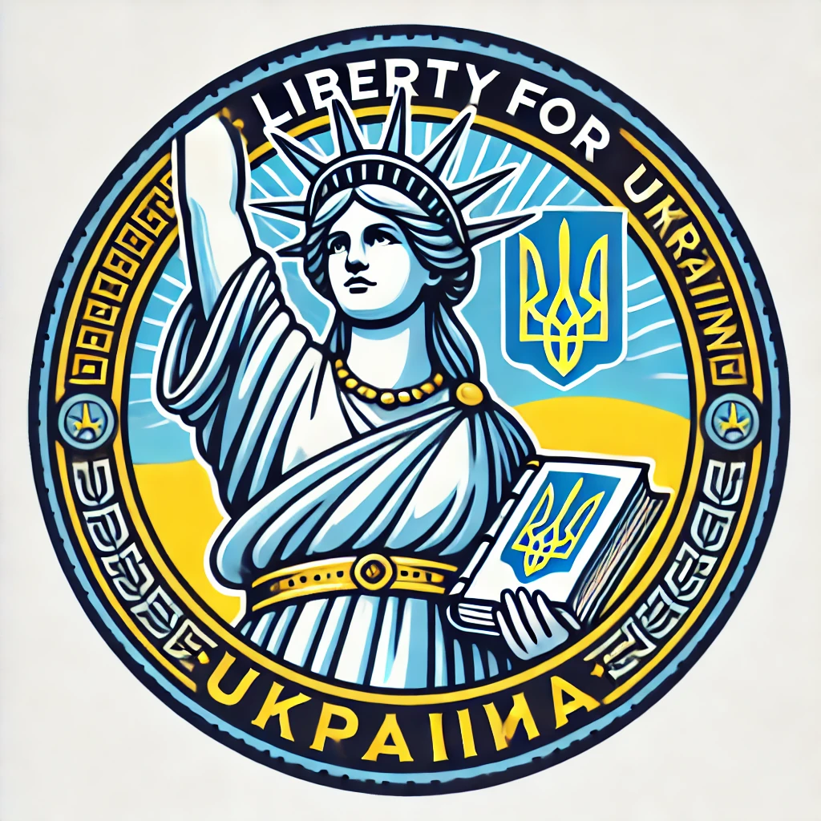

Liberty for Ukraine

January 15, 2025

Contents

Introduction 4

1. US Efforts to help Ukraine during the War 4

1.1. Claimed Purposes of Financial and Governmental Support 4

1.2. Humanitarian Aid Embezzlement 4

2. US Efforts to Support the Freedom of Ukraine Media 6

2.1. Claimed Purposes of Media Support 6

2.2. Radio Free Europe - Radio Liberty 6

2.2.1. Vitaly Portnikov 6

2.2.2. Yevhen Dykyi 8

2.3. ATR TV channel 9

2.3.1. Aider Muzhdabaev 9

2.4. US Media Support Factual Results 10

3. US Efforts to help Ukraine fight corruption 11

3.1. Claimed Purposes of anticorruption programs 11

3.2. Ukraine partners of US bodies and programs 11

3.3. Anti-corruption measures ineffectiveness 12

3.3.1. Booming Ukraine Luxury Car Market 12

3.3.2. Military Food Procurement Scandal 13

3.3.3. Ukraine’s Antarctica Research 14

3.3.4. Musical Instruments and Lego Sets for Bomb Shelters 15

3.4. Ongoing Steps to Decrease Transparency 17

3.5. Factual Results of US Anti-corruption Policy in Ukraine 18

4. Human Rights and Democracy Support in Ukraine 18

4.1. Human Rights Organizations in Ukraine 18

4.2. Human Rights Abuse in Ukraine 19

5. Historical Parallels 19

6. Incentives for the USA to Help Ukraine 20

Conclusion 21

Appendix A – Information Sources 22

# Introduction

This report aims to lay the groundwork for redirecting U.S. budget funding from a few civilian projects in Ukraine to military support. The report presents facts about the spending of U.S. budget funds on programs in Ukraine that lead to undesirable or illegal consequences:

* Corruption in Ukraine increases during the period of U.S. grants but does not decrease.
* interference in U.S. elections through biased media coverage, which creates pressure both internationally and on the Ukrainian diaspora in the United States.

This document provides examples of corruption in Ukraine and its detrimental impact on the country's ability to defend itself from Russian aggression. Historical examples are used to assess the effectiveness of the Ukrainian state in comparison with another state during a similar war. Arguments are presented showing that the defeat of Ukraine is not in the strategic interests of the United States.

The desired outcome of this document is to persuade representatives in the US Congress to reconsider US fiscal policy towards Ukraine, including ending US budget funding for ineffective anti-corruption and media efforts in Ukraine and increasing support for the Ukrainian army to enhance its defense capabilities.

# US Efforts to help Ukraine during the War

## Claimed Purposes of Financial and Humanitarian Support

Between January 24, 2022, and October 31, 2024, the USA made $26,90 billion in financial disbursements and $3,68 billion in humanitarian disbursements. That makes $10 billion and $1,4 billion on average in a year.

Financial support is being performed primarily through the Department of State and ‘Economic Support fund for Ukraine and neighboring region’. The main intention is to provide vital economic and budgetary support for the Government of Ukraine.

Humanitarian support is being performed primarily through the U.S. Agency for International Development (USAID) and its multiple humanitarian programs. [44]

## Humanitarian Aid Embezzlement

In March 2022, at the beginning of the Russian-Ukrainian armed conflict, large batches of humanitarian aid were sent to Ukraine from the EU, Canada, and the United States. In particular, humanitarian aid worth over 100 million US dollars was sent to the Zaporizhia region.

According to information verified by the Foreign Intelligence Service of Ukraine (SVRU), most of this humanitarian money was stolen and used for their own benefit by an organized group of people. That group consisted of high-ranking officials from the leadership of the regional military administration (OVA) and the mayor's office of Zaporizhia.

The main role in receiving and distributing humanitarian aid belonged to Zlata Nekrasova, deputy head of the OVA in the Zaporizhia region in 2022. Active assistance in this action was provided by a business partner who had a personal relationship with her - Viktor Shcherbina (a monopolist in funeral services in the city of Zaporizhzhia, who maintained a link between Zlata Nekrasova and the acting mayor of the city of Zaporizhzhia - Anatoly Kurtev. The entire vertically integrated system of the theft of humanitarian aid was supervised by the Deputy Head of the Presidential Office (OP) - Kyrylo Tymoshenko. According to available data, humanitarian aid arrived by rail, by road and by sea (in sea containers).

The illegal sales scheme was organized in such a way that humanitarian aid was unloaded during the curfew to minimize the witness base. Sometimes, according to the order of the OVA - Starukha Oleksandra, the curfew was extended by two days (usually on Saturday and Sunday).

Perishable goods (fruits, vegetables) and food batches, alcoholic beverages, canned goods, semi-finished products, cereals, pasta - were sold through the supermarket chain "Epicenter", "ATB", "Silpo". Industrial goods were sold through "Epicenter". Pharmaceutical products were sold through the pharmacy chain "ANTS" - pharmacy of low prices, "Optika". Security and physical escort of humanitarian cargo was carried out by forces and means of the SBU in the Zaporizhzhia region (Office of the Security Service of Ukraine).

After obtaining the results of the operational search actions of the SVRU, the defendants in the criminal case ordered Colonel Viktor Zaitsev - a close connection of Viktor Shcherbina to fabricate a criminal case against the SVU officer Colonel Olexander Kvitko. The case was fabricated on the grounds of Art. 111 of the Criminal Codex of Ukraine. The case was fabricated with episodes of alleged connections with the agent network of the FSB of the Russian Federation.

As a result of the operation to suppress the activities of the organized crime group in humanitarian aid, it was established that the defendants in the case stole the following in especially large quantities:

- 249 trucks;

- 22 sea containers;

- 349 railway cars.

Information about the above episodes is available on the NABU websites and on Internet resources. [45]

Gleb Rumyantsev also took part in the operational activities. A criminal case has also been opened against him. He is currently under investigation and is in the Kyiv pretrial detention center. The criminal case 22022000000000718 from 27.12.2022 is against both Kvitko Alexander and Rumyantsev Gleb. These materials were prepared using the help of Oleksandr Dubinsky’s layers, who is in detention and goes through multiple court hearings.

According to official USAID statistics only, 182 abuse aid cases of USA support have taken place from the beginning of February 2022. [46] That shows that humanitarian aid is often misused. In the case in the Zaporizhia region, the authorities try to cover the theft and punish the investigators.

# US Efforts to Support the Freedom of Ukraine Media

## Claimed Purposes of Media Support

The US has several programs in Ukraine that are aimed at the media sector, among them:

1. The United States Agency for Global Media (USAGM) is a networked global media agency. The six entities that comprise the USAGM complement and reinforce one another in a shared mission vital to U.S. national interests: to inform, engage, and connect people around the world in support of freedom and democracy.
2. Department of State (the U.S. Embassy in Ukraine), Media Development Fund (MDF) Program ($500,000 in FY24). The MDF program is striving to support efforts that are essential for sustaining independent reporting, safeguarding press freedom, and promoting accountability in governance, thereby contributing to the resilience of Ukrainian society. [3]

## Radio Free Europe - Radio Liberty

USAGM is intended to support independent journalism in regions where the free press is threatened. It supports the Kyiv bureau of Radio Free Europe/Radio Liberty (RFE/RL). [1] The RFE/RL budget is $142.2M in 2024. [43]

## Vitaly Portnikov

Vitaly Portnikov (Ukrainian: Віталій Едуардович Портников, romanized: Vitalii Eduardovych Portnykov; born 14 May 1967) is a Ukrainian editor and journalist. A columnist for Radio Liberty and a regular author of analytical articles in Ukrainian publications on political and historical topics. [9]

One of the most popular Ukrainian journalists Vitaly Portnikov is the editor and host of the program “Roads to Freedom” on Radio Liberty (Figure 1).

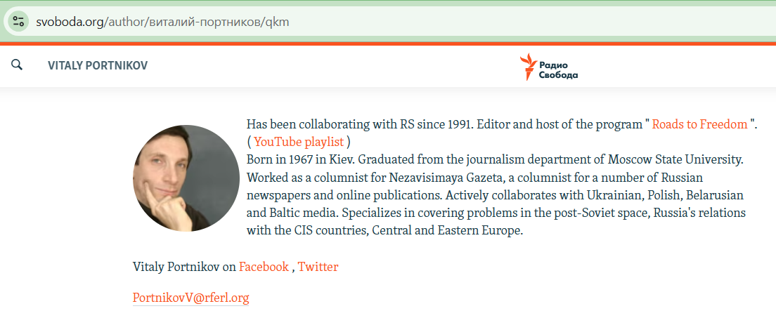

Figure 1 – Vitaly Portnikov's page on the official Radio Liberty official website [2]

Quotes from Portnikov’s interview on July 19, 2024:

“Donald Trump will do as Donald Trump thinks, well, he is such a person. You have seen him. He is a person with an excessive ego who beats in the chest those who try to cover him in photos, literally at protocol ceremonies. He is a person with a rather unhealthy psyche, well, such is the reality, but look what charisma. Look at what. Look at what courage. A person who goes to a meeting with bullets. A person allows us to remember the same politicians of the 1930s, the centenary of Adolf Hitler, Benito Mussolini, …”

“Co-host: ‘- We often hear that there are no figures in world politics who are able to oppose Putin, there is also such an opinion.’ Portnikov: ‘- Oppose Putin? Maybe he can agree with Putin on such terms that Putin will like? Why to him, If the United States wants to leave Europe, they believe that Europe is no longer the center of influence of the United States, that Europe must ensure its own security, and Vladimir Putin claims some unfortunate people there, peripheral states in Eastern Europe. So, what is the dispute between America and Russia about, then? Well, Joseph Biden has a value dispute. He believes that international law should be respected. He believes that the people’s choice should be respected. These are classic liberal democratic values. And if Donald Trump believes that the main thing is, it is America's interests. America's interests are to expand its influence in the Asia-Pacific region, then the focus on this Ukraine in Europe only distracts the Americans from competition with China. So, what should he have a conflict with Vladimir Putin about? Where do they even have the subject of conflict?’” [4]

## Yevhen Dykyi

Yevhen Oleksandrovich Dykyi (born August 28, 1973, in Kyiv) is a Ukrainian scientist, publicist, military officer, and public figure. A participant in the war in eastern Ukraine in 2014, he served as a deputy platoon, demobilized in the summer of 2014. Since February 2018, he has headed the National Antarctic Research Center. [5] He is a frequent guest on Radio Liberty. (Figure 2) 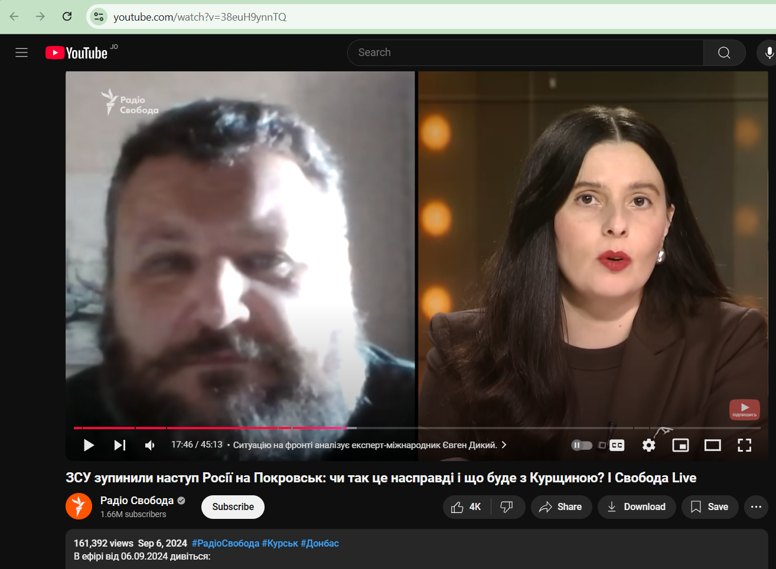

Figure 2 – Yevhen Dykyi's appearance on Radio Liberty as a military expert, Sep 6, 2024 [6]

Below is the passage from his interview to ‘Marathon’, on Jul 14, 2024. ‘Marathon. Straight. Day’ is part of the "Єдині новини" ("United News") information marathon, a collaborative broadcasting initiative. The ‘Marathon’ is coordinated with the involvement of the Office of the President and other state bodies to maintain a unified information policy. [7]

“I'm just saying that yes, judging by everything, we really have a boy who just saw for himself what was happening, saw that it turns out that democratic institutions are not able to protect themselves, that it turns out that there is one person and his supporters, well, roughly speaking, stupid rednecks, by and large, that they can hack democracy, and no one is able to stop this victorious march by legal methods, and so he found the way out that he found for me. By the way, it's very infuriating that no one feels sorry for him. No one publicly tells him that he feels sorry for him. And everyone, on the contrary, specifically emphasizes that it's a pity for that Trumpist who was accidentally killed at this rally. Well, listen, you go to the Führer's rallies, well, be prepared for an anti-fascist to shoot you. That's normal. But the guys really feel sorry for him. The guy sacrificed himself. He tried to save the world. Unfortunately, he didn't succeed, but honor and praise be to him.” [8]

## ATR TV channel

ATR is a Ukrainian TV channel, previously one of three Crimean TV channels broadcasting in Crimean Tatar, Ukrainian, and Russian. Aider Muzhdabaev is a deputy general director there [10]

According to their official website, this project was supported by the Media Development Fund of the U.S. Embassy in Ukraine (Figure 3).

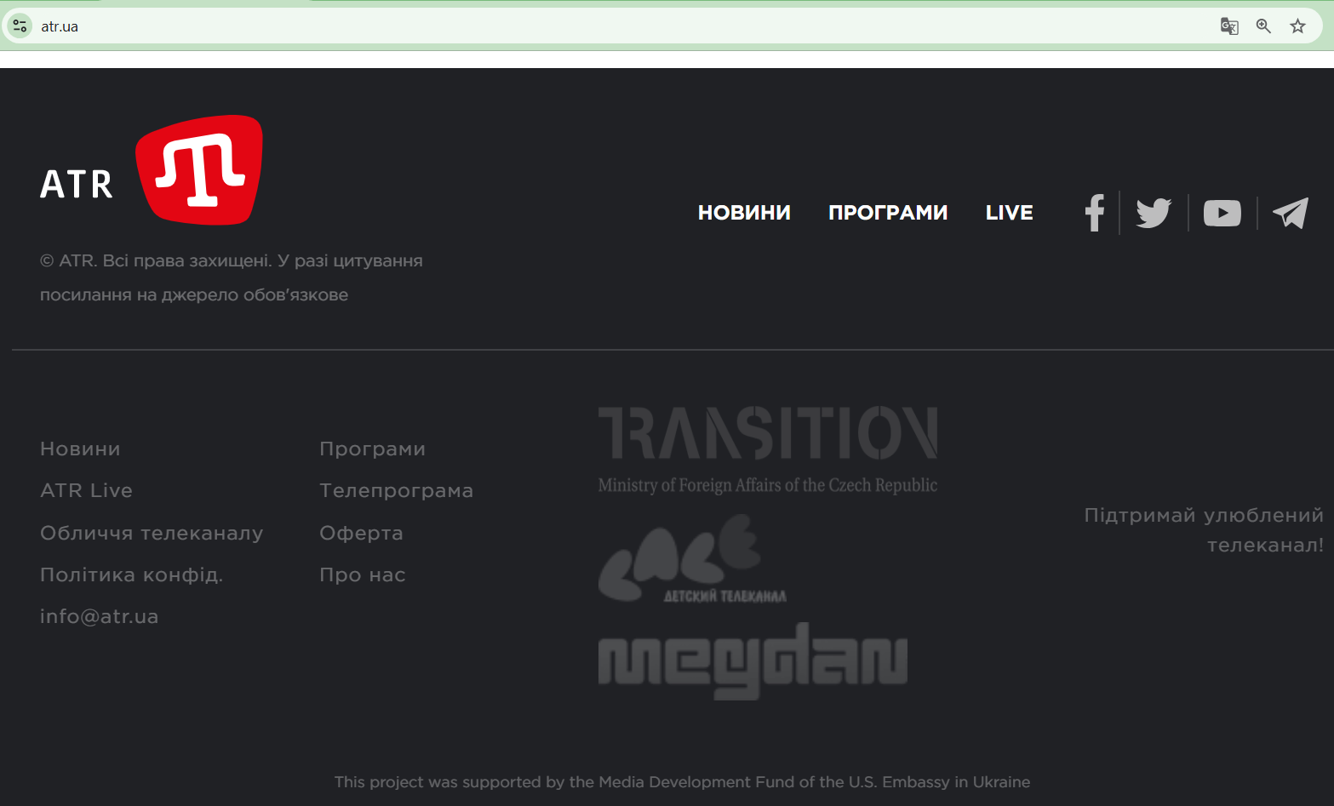

Figure 3 – Key supporters of ATR TV channel, official website [11]

## Aider Muzhdabaev

Ayder Izzetovich Muzhdabayev (Crimean Tatar: Ayder İzzet oğlu Mujdabayev; born March 8, 1972, Tambov) is a Russian and Ukrainian journalist and media manager. Deputy editor-in-chief of the Moskovsky Komsomolets newspaper (2008-2015), member of the Union of Crimean Tatars of Moscow. Deputy Director General of the first Crimean Tatar TV channel ATR (since 2015). [12]

Quotes from Muzhdabaev’s interview on October 21, 2024:

“Co-host: ‘- but you think that there is another country that can be compared to the ‘fifty-first’ state? (of USA)’ Muzhdabaev: ‘- Well, Moldova is just a state with a population of somewhere under three million 2-3 million. That’s where the participation of voters is the head of Russian propaganda and where bribery politicians, journalists, bloggers, public figures that’s where having elected in Moldova, I just recorded a video today and posted it on my site, look at it, extrapolate it on every America swing state, how they act, how they will act in America. That is, but the consequences in America can be completely different. I do not know how it is going to end up in Moldova, but the fact, that in America, Trump can raise a riot, and somehow Biden, if he miscalculated so much with the attorney general, we need to prepare for this because we must, there should be some clear answers, an algorithm of actions. I hope that they are sitting there, not counting flies, thinking about something. Because if he then called for storming the Capitol when almost all sane people were in his entourage, except him. Now, when there is not a single one sane in his entourage, I think he will go to all lengths, I think they will blockade the election commissions, they will replace the electors, they will spit on all traditions of the previous American elections. American legislation is written for honest good Christians. Here, there is no smell of good Christians, but there is a smell of fraud with Russian money, and all sorts of manipulation. They, of course, will not recognize the elections. And there are those states where he lost, for example, well, for example, in Pennsylvania or Wisconsin. If it will be of decisive importance, they will arrange such things for you that, I don’t know, Moldova will seem an easy walk.” [13]

## US Media Support Factual Results

As is clearly seen from previous chapters, there are multiple occasions when there is one-sided propaganda in Ukrainian media:

* Representing Trump as fascist and criminal, encouraging violence against him, and expressing empathy to his assassinator.
* Representing supporters of the Republican party as stupid people without a moral compass.
* Smear Trump and the Republican Party by portraying them as Putin supporters.

Those facts show the ineffectiveness of US media support programs in Ukraine. Supported US media outlets do not oversee the people they allow access to their broadcasting services. This shows the deviation from the US mission to instill independent journalism and people’s access to objective information in Ukraine.

Moreover, the Ukrainian state representatives have not condemned the case with the call for violence against Trump, which occurred on the state-controlled media. This fact casts a shadow on Ukraine as it does not adhere to the principles of democracy here and raises questions about the rationality of the US support of the Ukrainian state.

# US Efforts to help Ukraine fight corruption

## Claimed Purposes of anticorruption programs

The US has several programs that are aimed at helping Ukraine to combat corruption, among them:

1. Department of State (the U.S. Embassy in Ukraine), International Narcotics and Law (INL) Enforcement Affairs Office. The INL Section is responsible for coordinating and implementing criminal justice and law enforcement reform and technical assistance programs in Ukraine funded by the Department of State. It implements assistance programs to combat corruption, organized crime, narcotics trafficking, economic and financial crimes, trafficking in persons, and other criminal activity. [14]
2. The United States Agency for International Development (USAID) is the United States government agency that leads international development and humanitarian assistance efforts to partner countries. USAID’s efforts provide humanitarian assistance, reduce poverty, enhance transparency, and strengthen democratic governance. It has several anticorruption initiatives, for example:

* Anti-Corruption Champion Institutions (SACCI) program. [15]
* USAID and UKAid Anti-Corruption Initiative. [16]
* Digital Transformation of Ukraine. [17]

Since 1992, USAID has contributed more than $3 billion in assistance to Ukraine in total. [24] 2025 Budget Request for USAID: The request includes $482 million for Ukraine, of which, $321 million is for USAID fully or partially managed accounts to help respond to the increased economic, development, and security needs, including bolstering energy infrastructure in the wake of systematic targeting by Russia, improving cyber security, growing the agricultural sector to generate exports, and supporting civil society including activists, journalists, and independent media. [42]

## Ukraine partners of US bodies and programs

The INL office works closely with the Office of the President, the National Anti-corruption Bureau (NABU), the Ministry of Justice, the Office of the Prosecutor General, the Ministry of Internal Affairs, the National Police, the State Border Guard Service, the State Customs Service, and other Ukrainian agencies. [14]

The Anti-Corruption Action Centre (AntAC) aims to develop and promote draft laws, initiate consideration of laws about NABU, control public procurement, identify and prevent corruption schemes in the procurement of medicines, create an open state register of beneficial owners of legal entities and open access to the register of property of individuals, and launch an electronic declaration system. [23]

The Anti-Corruption Action Center (ANTAC) receives significant funding from international donors, including USAID. In 2023, USAID's contribution was 19.7% ($199,404) of the total financing of $1,012,208. USAID has been supporting ANTAC since 2014, contributing a total of $4,363,627, which is 20.7% ($1,524,270) of the total financial support. [18]

## Anti-corruption measures ineffectiveness

## Booming Ukraine Luxury Car Market

The Luxury Cars Market segment includes passenger cars with an average footprint of around 5m2 (54 ft2), an average mass of around 2200kg (4850 lbs) and a passenger/cargo volume larger than 3.4 m3 (120 ft3). Models in this market are characterized by their high prices. Examples of models: Audi A8, BMW 7 Series, Jaguar XJ, Mercedes-Benz S-Class, and Porsche Panamera. [19]

The figure below (Figure 4) highlights the key trends in the luxury car market in Ukraine from 2016 to 2024. Despite the war, the premium automotive sector has shown resilience and significant growth, especially in 2023 and 2024.

“According to Global Euronews, sales of luxury cars in Ukraine broke all sales records for the 2023 calendar year and extended the sales bonanza into 2024. The Association of Automobile Manufacturers of Ukraine noted that 5000 new cars were sold in one month between June-July 2023.” “The publication reported the increase mainly came from a surge in demand for premium models.” [20]

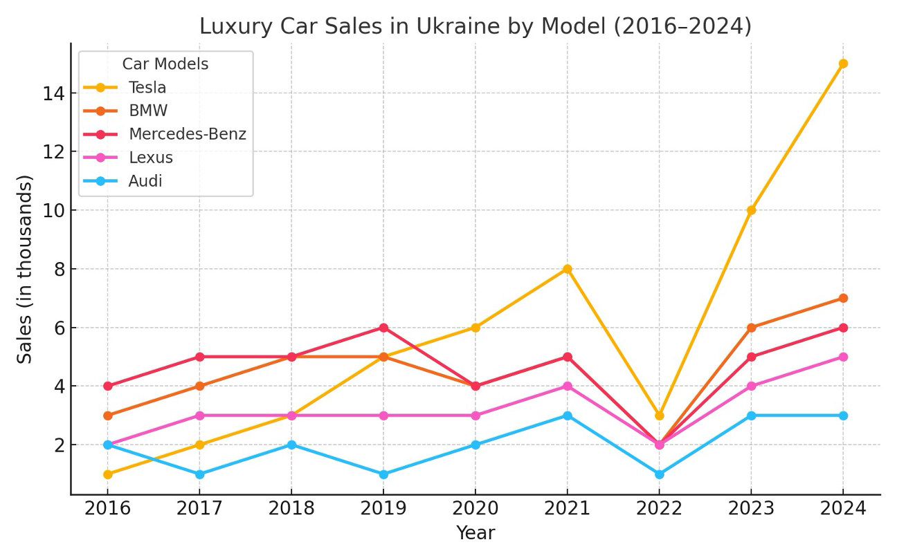

Figure 4 – Luxury car sales in Ukraine [19]

“One of the reasons for this may be the cancellation of the obligation of officials in Ukraine to file declarations, which was explained by the military situation in the country.” [21]

“If so, it is understandable why the president and MPs, under the pretext of war, do not want to disclose the statements of officials to citizens, who may be shocked by what they see”, – commented the portal ‘Our Groshi’.” [21]

“Journalists' investigations have repeatedly shown that it is officials who are one of the drivers of this market. Among them are the family of the head of the Antimonopoly Committee, judges and prosecutors, people's deputies and even military commissars.” [22]

“This is unbelievable and provides hard evidence that some Ukrainians are doing quite well while the rest of the country turns to rubble.” “The level of corruption, which has not decreased despite the assurances of President Volodymyr Zelensky, who said at the end of 2022 that all the corrupt had left the country.” [20]

## Military Food Procurement Scandal

There was “an agreement of the Ministry of Defense for catering services in 2023”. The contract worth 13.16 billion UAH ($482 million) was concluded by the Ministry of Defense with LLC "Aktiv Kompani" on December 23, 2022.” “The agreement with "Aktiv Kompani" was signed on behalf of the ministry by Bohdan Khmelnytsky. He was wanted because of the connection with the case of embezzlement in the supply of ammunition for the military.”

“Prices for the most popular foods turned out to be 2–3 times higher.” “Before the invasion, in 2021, the prices in the contract, the deviation from market prices for products in last year's Ministry of Defense contract was relatively insignificant — up to 20%.” The procurement prices before the invasion were saved by chance, because “the state decided to hide information about all military purchases, including those carried out in previous years.”

In 2021, the tax service canceled the VAT payer certificate of this company due to the lack of deliveries and failure to submit declarations. In 2019, LLC "Aktiv Kompani" appeared in criminal proceedings of the National Police No. 12019100100003229. The company allegedly submitted a forged act. [25]

“Speaking at a specially convened session in parliament, Ukraine’s Minister of Defense Reznikov responded, claiming that the comparison is incorrect.” “Members of parliament urge to return to transparency even during martial law, to avoid mistrust” The “deputy minister of Defense Viacheslav Shapovalov decided to resign on 24 January 2023”, which was the only outcome from this story. [26]

## Ukraine’s Antarctica Research

The National Antarctic Research Center (NARC) is Ukraine's state operator in Antarctica. It is a state research institution within the Ministry of Education and Science of Ukraine that ensures the operation of the Ukrainian Antarctic Station "Akademik Vernadsky" and coordinates Antarctic research in Ukraine. The director there is Dykyi Yevhen Oleksandrovych, [27] who is by chance the key figure of, yet another scandal covered in this document in chapter 2.2.2. NARC owns and keeps operational at least two ships: the icebreaker "Noosphere" [28] and the ecological monitoring vessel "Boris Alexandrov". [29]

Akademik Vernadsky was founded in 1947 as the British Faraday Station. In February 1996, it was transferred by Britain to Ukraine for free. It is financed from the government budget. For the current year (2024), the program provides 557.6 million UAH ($13 million) in expenses for the station in Antarctica. [31] In 2022 and 2023, it receives 283 mil UAH ($9 million) and 590 mil UAH ($16 million). [30] The British ship James Clark Ross was sold to the National Antarctic Scientific Center of Ukraine, in August 2021 and became "Noosphere". [28]

On May 27, 2024, there was “A tender was noticed in the Prozzoro system under the title "Comprehensive service for logistical support of Ukrainian Antarctic expeditions using the scientific and research oceanographic vessel "Noosphere" (IMO No. 8904496)". This concerns the expedition's expenses for technical equipment, food, and the transportation of scientists.” “The tender worth was $11.6 million” “Ukrainians on social media expressed outrage at the expenses, which include plans to purchase octopus, salmon, wine, and caviar for the expedition participants.” [32]

“On December 10, 2024, he signed an agreement worth $579,357 with the Estonian company WINOT OU. According to journalistic investigations, WINOT OU is a fictitious company controlled through offshore schemes. Its activities are closely linked to dubious Ukrainian businessmen, including Andriy Chuklin, who is suspected of numerous corruption scams, and Oleksandr Moshensky, a Belarusian businessman with an ambiguous reputation.” [33]

The public questions about the rationality of supporting Ukraine's polar activities at the present level during wartime were deemed short-sighted, as well as questions about scams. [34] Anatoliy Shariy, the Ukrainian opposition blogger was framed as: “the first to spread the relevant information was pro-Russian blogger Anatoliy Shariy, who is hiding from Ukrainian justice in the European Union.” [34] There were no signs of the ongoing investigation of NARC till December 19, 2024. [33]

## Musical Instruments and Lego Sets for Bomb Shelters

Department of Education of the Dniprovska District in the City of Kyiv State Administration decided to buy some items for kids to entertain themselves in bomb shelters during the air raids.

At first, on April 20, 2023, an attempt was made to buy a set of six types of drums, 51 items in each type, and 153 sets of hammers (2 pcs.). The purchase was worth 891174 UAH ($ 24213). [35] Then they canceled that purchase and bought Lego (Figure 5)

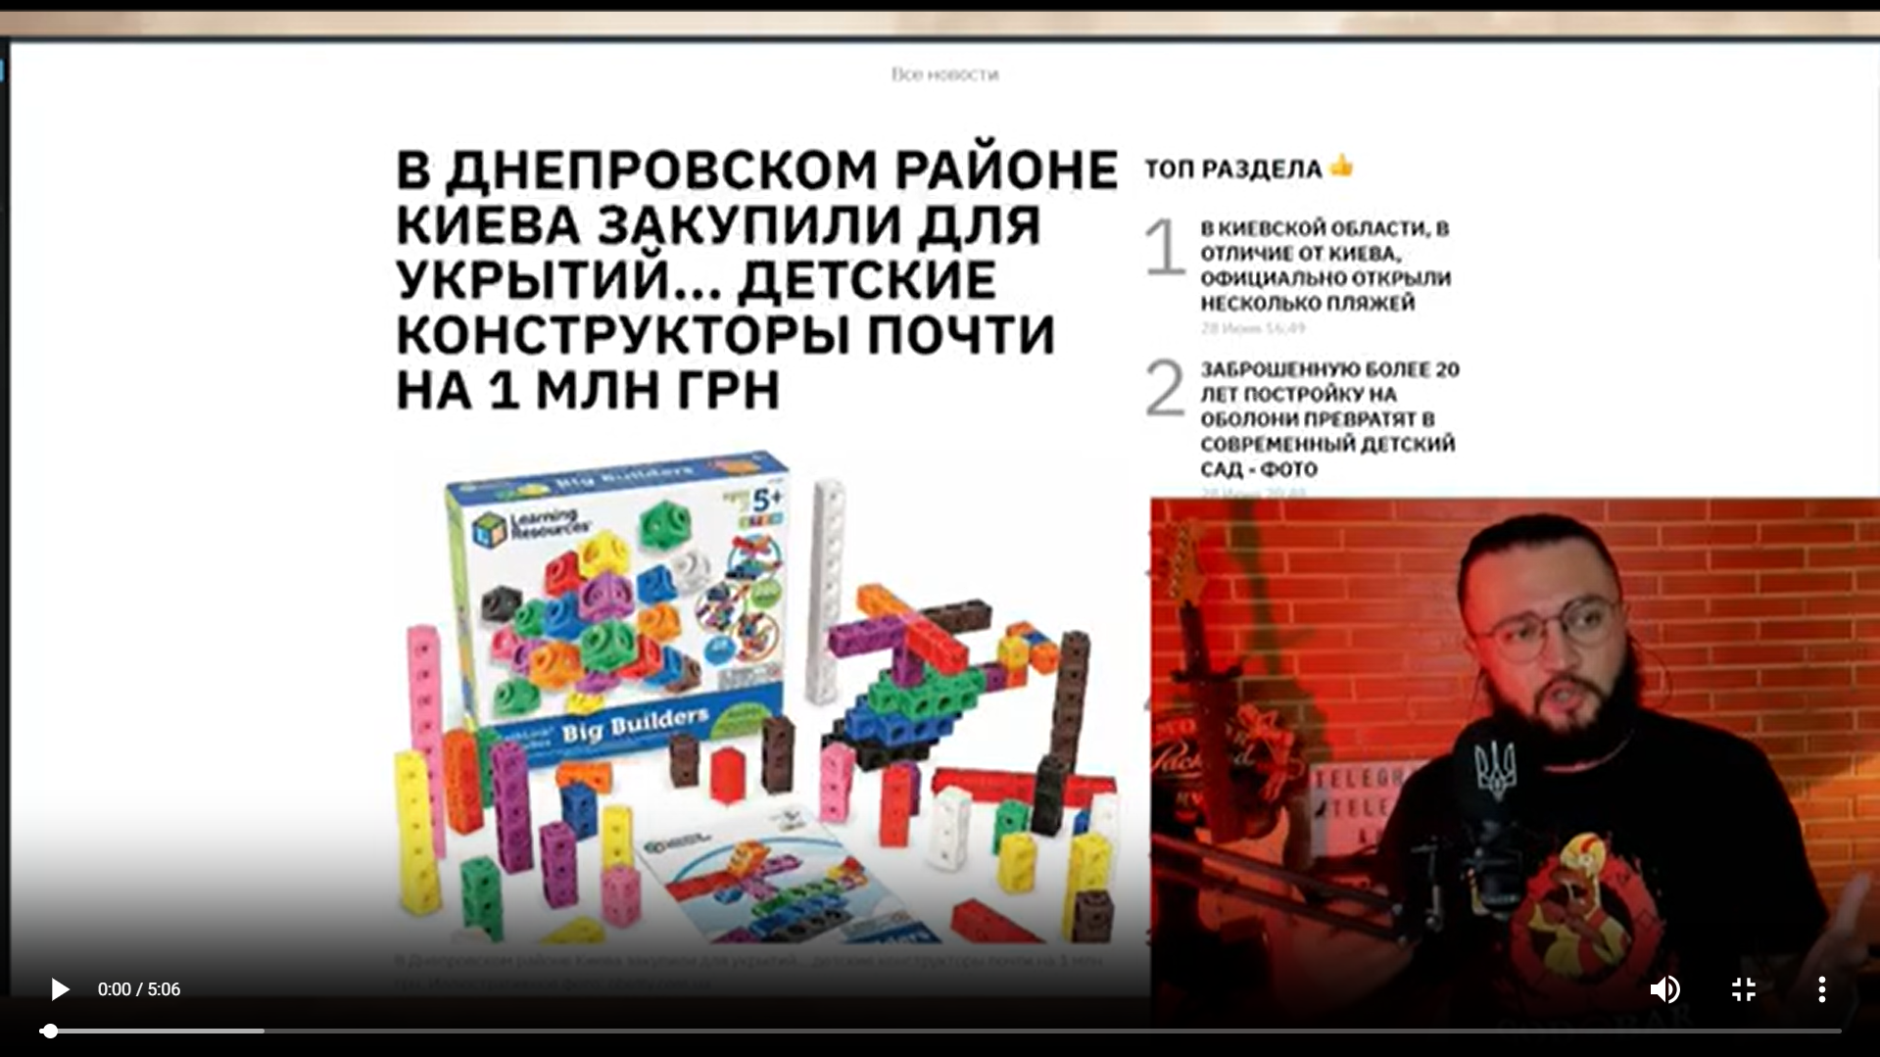

Figure 5 –Andrey Lugansky, the independent blogger on the Lego purchase [36]

The tender contained 113 sets of ‘Wall-mounted construction set’ and 390 sets of ‘Developing mathematical constructor’. The purchase was worth 952864 UAH ($ 25889). The contract was finalized on May 03, 2023, but later terminated without any money and goods transferred. [37] Andrey Lugansky also mentioned that the state of most bomb shelters during the time of purchase was inadequate (Figure 6)

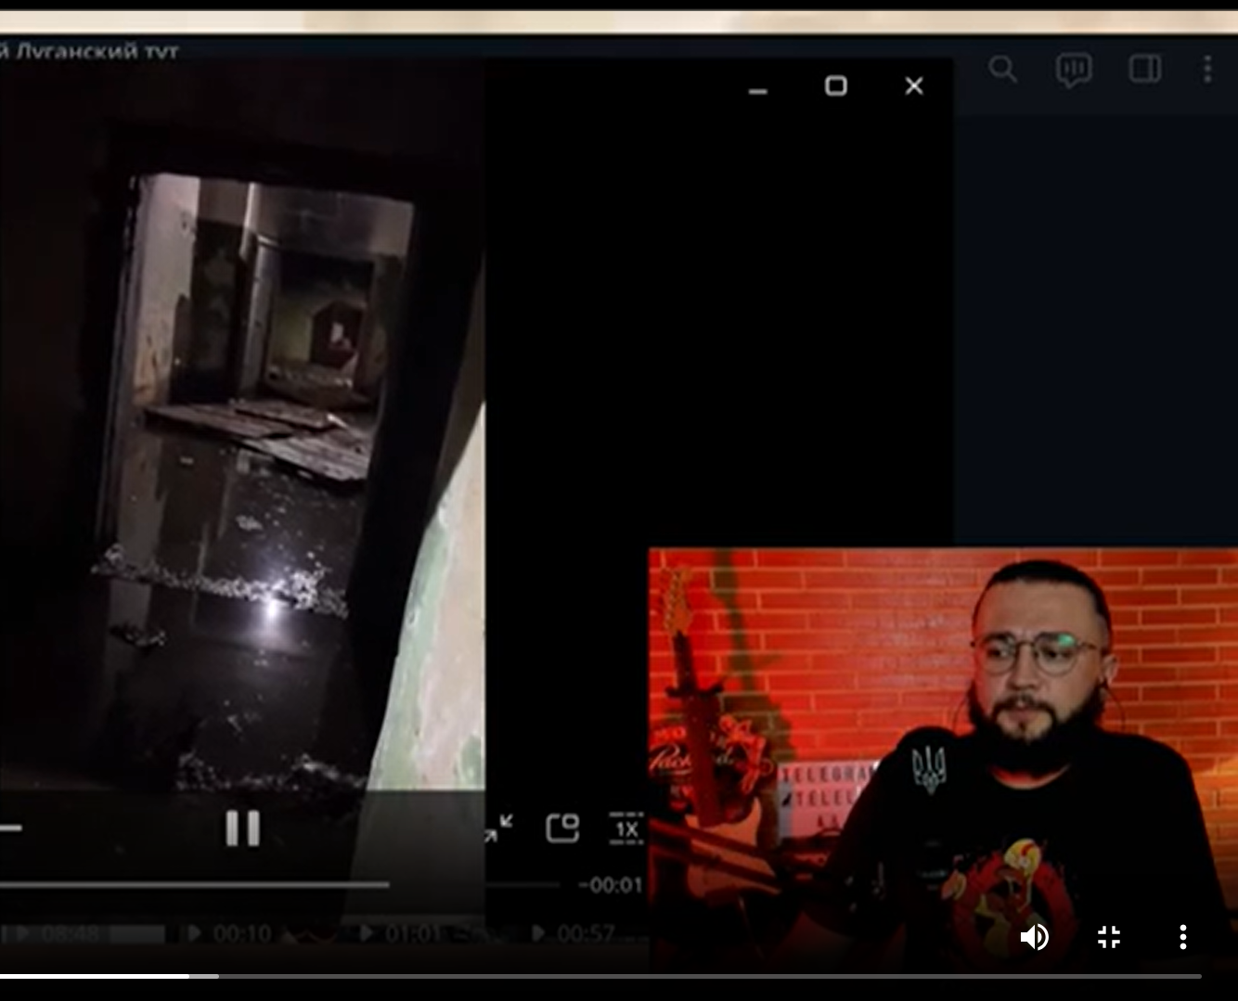

Figure 6 –Andrey Lugansky, shelter on Patsaev Street under the children's play center "Crazy Land" [36]

Another information source confirms Lugansky’s shelter assessment: “The results of the inspections showed that out of more than 4.6 thousand shelters and storage facilities in Kyiv, 65% are suitable. The government stated that only up to 15% of the capital's shelters have no issues.” [38] No investigation was opened regarding either of those tenders.

## Ongoing Steps to Decrease Transparency

There is “the Draft Law on Amendments to the Criminal Code of Ukraine to Establish Criminal Liability for Unauthorized Interference, Sale or Distribution of Information Processed in Public Electronic Registries and Strengthening Criminal Liability During Martial Law for Criminal Offenses in the Use of Information and Communication Systems”.

That law will make life harder for journalists and independent investigators because they will soon be obliged to receive approval from authorities to publish data from electronic registers (such as Prozorro). They will face up to eight years in prison in case of violation. The officials explained it by the need to hide information from Russian spies. The law draft was adopted as the basis and went through several hearings in the Ukrainian parliament, the last one took place on December 18, 2024. [41]

The Parliament of Ukraine adopted yet another law on January 15, 2025. Mass media are obliged to delete negative comments about officials in the news. It is necessary to delete the comment within 3 days after the complaint. Failure to do so will result in prosecution. Those can be any comments that contain accusations of corruption, violation of the law, or simply "offensive" statements. [61]

## Factual Results of US Anti-corruption Policy in Ukraine

As is clearly seen, there have been multiple occasions when corrupt bureaucrats got away easily. All cases covered in this chapter received wide public exposure, yet no single person was convicted of those crimes.

Those facts show the ineffectiveness of US anti-corruption programs in Ukraine. It also shows the lack of determination among Ukrainian officials in the fight against corruption. Some evidence even suggests attempts to hide those issues.

This fact also casts a shadow on Ukraine as it does not adhere to the principles of democracy here and raises questions about the rationality of the US support of the Ukrainian state.

# Human Rights and Democracy Support in Ukraine

## Human Rights Organizations in Ukraine

USAID policy claims to fight restrictive media laws, laws governing non-governmental organizations (NGO), and harassment or persecution of civil society activists that have limited freedom of speech and association in many places. There are many human rights organizations in Ukraine that hold that agenda:

1. Ukrainian Helsinki Union: mainly provides human rights organizations in Ukraine to attract legal people to help them conduct open programs. It is funded by USAID, the Renaissance Foundation (Soros), the Mott Foundation (Headquarters: Flint, Michigan, USA), Chemonics (Chemonics International is based in Washington, DC), the Martta Ahtisaara Peace Foundation (EU: Helsinki, Brussels), Bureau of Democracy, Human Rights and Labor (DRL) (US Department of State). [47]
2. Center for Civil Liberties: an organization that monitors people's rights, and promotes and takes active initiatives. It is financed by Open Society Foundation, NED, State Department of the USA, SIDA, EUROPEAN COMMISSION, UNDP, SIGRID RAUSING TRUST, USAID, and Building Local Promise. [48]
3. Kharkiv Human Rights Group (KHRG) - monitors the rights of people who have the right to assistance and visible duration. It is funded by the European Union, DIGNITY, USAID, People in Need, Prague Civil Society Center, US Embassy in Kyiv, and European Prison Litigation Network. [49]
4. ZMINA Human Rights Center: engages in obtaining information about human rights in Ukraine and conducting advocacy campaigns. It is funded by the US Department of State, UNDP, and the Renaissance Foundation (Soros). [50]
5. NGO "Media Initiative for Human Rights" - engaged in Advocacy for changes in government policies and social practices regarding the provision and observance of human rights and freedoms. It is funded by the Renaissance Foundation (Soros). [51]
6. The Institute of Mass Information (IMI) is a leading Ukrainian media NGO. IMI is engaged in the preparation of analysts in the field of freedom of speech. It is in partnership with: USAID, OSCE, UNESCO, N-ost, and UCBI. [52]

## Human Rights Abuse in Ukraine

There are many occasions when people suffer from illegal detention, torture, sexual abuse, and beatings in the Territorial Center of Recruitment and Social Support (TCR) as well as in the ‘gym’ concentration camp, which was located in the SBU building, Vladimirskaya, 33, Kyiv.

## SBU Concentration Camp “Gym”

“OHCHR received credible information from numerous conflict-related detainees and prisoners of war about an unofficial detention facility located in the gym and basement of the central SBU building in Kyiv, where up to 70 persons (mostly men, but also some women) were held at any one time. OHCHR documented that the unofficial detention facility operated from February 2022 until at least November 2022… They were allowed to use toilets three times a day, but were given food only once or twice a day; they received water in small quantities. Several interviewees reported being blindfolded for the entire period of their detention, which lasted up to a month.

OHCHR notes that the practice of holding detainees in unofficial detention facilities, where they are not protected by law, appears to have been used to coerce detainees into confessing or making self-incriminating statements, sometimes recorded on camera. Interviewees told OHCHR that the stress and fear caused by isolation and secret detention pressured them to confess to acts they did not commit.

In May 2022, a civilian man was held for seven days in an unofficial place of detention at the local SBU office in Kryvyi Rih, where he was tortured for three days in a row. After receiving the results of a polygraph test that he was forced to take, SBU officers beat him again, hitting him in the head, ribs, and legs. After stripping him, they threatened to cut off his genitals, rape him, and send the video to his children.” [56]

“One of the victims filed a formal crime report with the State Bureau of Investigation (SBI) of Ukraine... The SBI did not initiate a criminal investigation within 24 hours as required, but only five months later, in February 2023, disregarding two prior orders from investigative judges that had required them to act promptly. Following an additional five months of pre-trial investigation, the SBI closed the investigation, asserting a lack of evidence of criminal misconduct.” [55]

One of the victims that went through “gym” was the only witness on whose testimony the charges against Dubinsky are based. Dubinsky claims that he holds evidence of corruption schemes of the Biden family connected to ‘Burisma Holdings’ business affairs in Ukraine. Thus, he interprets the charges against him as political prosecution. [57]

## Abuses of Power in Territorial Centers of Recruitment

“In the process of mobilization, namely illegal detentions, torture, beatings people, including the death of detainees after such actions at the end of March in Khmelnitsky TCR is an organization where the mobilization of people is carried out in as a result of torture, a young guy died.” [58]

“The Sambir District TCR is mocking Vadym, who is not yet mobilized, is calm the man was beaten with a pistol grip on the head and not only the trunk Vadym shot several videos, including here he is covered in blood and whispers for help, the man doubting that he could leave the premises alive, left evidence for law enforcement officers.” [59]

## Factual Results of US Democracy Support in Ukraine

Center for Countering Disinformation (CCD) in Ukraine, [54] which is a state body established in March 2021 under the National Security and Defense Council of Ukraine is used to ban political opposition journalists and bloggers, portraying them as ‘Russian propaganda’ [53]. Among those banned channels is ‘dubinskypro’, which is led by Oleksandr Dubinsky. [60]

The Human Rights Organizations listed above, which are funded by international organizations, both state and non-state, represented by the USA, effectively do not react to the total violation of human and civil rights and freedoms in Ukraine, namely: the illegal mobilization of the TCR, the kidnapping of people on the street by government representatives, their torture and murder in the torture chambers of the TRR and the SBU, the ban on freedom of speech.

# Historical Parallels

The situation in Ukraine resembles Finland's situation a century ago. Russia temporarily lost control over some of its peripheral territory in both cases. Finland used to be part of Russia till 1917. After the defeat in WWI and civil wars, Russia was in the restoration period. The same is true about the defeat in the Cold War (it can be called the first Cold War now) and the disintegration of the USSR. Russia tries to regain control over the peripheral countries after the state of its military and economy allow it to do that. Again, there were military conflicts during both those relatively calm periods.

The effectiveness of both states during conflicts can be assessed on several occasions:

1. The ability to mobilize the army during the conflict.

Finland: 320,000 troops, population: 3.7 million people, corresponding to 8,6 % of the population.

Ukraine: 1,080,000 troops, population:  28 million people (in Ukraine-controlled areas), corresponding to 3,9 % of the population.

1. The long-term defense strategy and building fortifications.

Finland: The Mannerheim Line was a defensive fortification line. During the civil war of 1918, the Finnish government and high command started to develop defense plans to protect against possible attacks from the Soviet Union. The first hundred small bunkers were built in 1920–1924. For reasons of cost, the first phase of hard fortifications were of unreinforced concrete. The Karelian defensive fortifications received considerably more funds and resources from May 1938, as the European situation worsened. [39]

Ukraine: “For the first time, the construction of large-scale defense on the eastern borders was discussed in the summer and fall of 2014.” “However, almost immediately, the initiative was mired in various scandals and anti-corruption proceedings over the embezzlement of public funds.”

“What was done under The Wall project before the start of the full-scale war:

* 403.5 kilometers of 4 by 2 meters anti-tank ditches were dug (instead of the planned 1,134 kilometers)
* 158 kilometers of barbed wire fence were built (instead of 194 kilometers)
* 185 kilometers of rocky roads were built (instead of the planned 1,129 kilometers)”

“Since 2014, the military has managed to build a defense line in the Donetsk region, which, to a greater extent (except in the south), was able to cope with a full-scale invasion.” [40]

1. Territory loss: Finland: 9%, Ukraine: 18% and growing.

This comparison shows the Ukrainian government's comparatively worse performance before and during the war, mainly due to corruption and poorer resource mobilization.

# Incentives for the USA to Help Ukraine

1. A Russian-dominated scenario in Ukraine is likely to lead to Russia launching another campaign to establish its influence in the countries of the former USSR or the Warsaw Pact. This could lead to a further increase in tensions in Europe and between Europe and the United States, deteriorating the USA's position in those regions.
2. Ukraine's possible demilitarization will give Russia access to military technologies that are used by NATO, as well as the newest and battle-proven.
3. The same scenario will demonstrate the United States' weakness as a player in the global political arena. This may encourage bad players, such as China or North Korea, to try to conquer territories that they believe are of interest to them. Russia could redirect its resources to help China get Taiwan, which is a possible scenario.

# Conclusion

As the report shows, there have been numerous instances in which Ukraine’s anti-corruption efforts and U.S. programs designed to support them have been ineffective. In addition, many programs to support democracy and media freedom have ended up as partisan propaganda projects. The Ukrainian government does not take military action seriously, as evidenced by its weak anti-corruption policies.

In total, the US budget appropriations to Ukraine were misused or even caused direct harm to the United States. Yet, the military defeat of Ukraine is not in the United States' interest. Thus, $482 million, mainly the USAID funds for 2025 FY, as well as USAGM, Department of State, should be redirected from the Ukrainian incapable state to the Ukrainian military to give Ukraine the upper hand in future peace negotiations.

# Appendix A – Information Sources

1. RadioFreeEurope - Ukrainian Service <https://about.rferl.org/service/ukrainian-service/>
2. Vitaly Portnikov - <https://www.svoboda.org/author/%D0%B2%D0%B8%D1%82%D0%B0%D0%BB%D0%B8%D0%B9-%D0%BF%D0%BE%D1%80%D1%82%D0%BD%D0%B8%D0%BA%D0%BE%D0%B2/qkm>

1. [U.S. Embassy in Ukraine](https://ua.usembassy.gov/" \o "U.S. Embassy in Ukraine) - Media Development Fund Program <https://ua.usembassy.gov/education-culture/grants-opportunities/media-development-fund-program/>
2. Trump and Third World (War) | Vitaly Portnikov @gvlua, Jul 19, 2024 (14:50-15:26; 16:04-17:13) <https://www.youtube.com/watch?v=9lmkKwtF7H8>
3. Dykyi Yevhen Oleksandrovych <https://uk.wikipedia.org/wiki/%D0%94%D0%B8%D0%BA%D0%B8%D0%B9_%D0%84%D0%B2%D0%B3%D0%B5%D0%BD_%D0%9E%D0%BB%D0%B5%D0%BA%D1%81%D0%B0%D0%BD%D0%B4%D1%80%D0%BE%D0%B2%D0%B8%D1%87>
4. The Armed Forces of Ukraine stopped the Russian offensive on Pokrovsk: is this really true and what will happen to Kurshchyna? I Svoboda Live, Sep 6, 2024 <https://www.youtube.com/watch?v=38euH9ynnTQ>
5. Television and power. How the telethon works from the inside and who oversees it <https://www.pravda.com.ua/articles/2022/06/21/7353715/>
6. 872-й день війни: ОСТАННІ НОВИНИ з фронту у марафоні
7. Vitaly Portnikov <https://en.wikipedia.org/wiki/Vitaly_Portnikov>
8. ATR (TV channel) <https://ru.wikipedia.org/wiki/ATR_(%D1%82%D0%B5%D0%BB%D0%B5%D0%BA%D0%B0%D0%BD%D0%B0%D0%BB)>
9. ATR TV channel official website <https://atr.ua/>
10. Muzhdabaev, Ayder Izzetovich <https://ru.wikipedia.org/wiki/%D0%9C%D1%83%D0%B6%D0%B4%D0%B0%D0%B1%D0%B0%D0%B5%D0%B2,_%D0%90%D0%B9%D0%B4%D0%B5%D1%80_%D0%98%D0%B7%D0%B7%D0%B5%D1%82%D0%BE%D0%B2%D0%B8%D1%87>
11. WHAT'S IN LIFE? Muzhdabaev & Rashkin | show #65, Oct 21, 2024, <https://www.youtube.com/watch?v=-GJU9evA9FI>
12. U.S. Embassy in Ukraine, International Narcotics and Law Enforcement Affairs <https://ua.usembassy.gov/embassy/kyiv/sections-offices/law-enforcement-section/>
13. Preserving Gains Against Corruption in Ukraine During Wartime <https://www.msiworldwide.com/projects/preserving-gains-against-corruption-in-ukraine-during-wartime/>
14. USAID and UKAid Anti-Corruption Initiative Launches in Ukraine <https://www.dai.com/news/usaid-and-ukaid-anti-corruption-initiative-pro-integrity-launches-in-ukraine>
15. USAID Administrator Announces Intent to Provide $650,000 in Assistance for Digital Transformation <https://www.usaid.gov/news-information/press-releases/jan-18-2023-us-supported-e-government-app-accelerated-digital-transformation-ukraine-now-ukraine-working-scale-solution-more-countries>
16. Financial reporting <https://antac.org.ua/support/#chart-section>
17. Luxury Cars – Ukraine <https://www.statista.com/outlook/mmo/passenger-cars/luxury-cars/ukraine?utm_source=chatgpt.com>
18. Ukraine is Experiencing Record Setting Luxury Car Sales <https://rvivr.com/2024/12/ukraine-is-experiencing-record-setting-luxury-car-sales/>

1. [Global Euronews](https://globaleuronews.com/) <https://globaleuronews.com/2023/08/12/premium-car-sales-soar-in-ukraine/?utm_source=chatgpt.com>
2. Elite Wheels: Why Luxury Car Sales Are Breaking Records <https://epravda.com.ua/rus/weeklycharts/2024/07/10/716457/>
3. Anti-Corruption Action Center (Ukraine) <https://ru.wikipedia.org/wiki/%D0%A6%D0%B5%D0%BD%D1%82%D1%80_%D0%BF%D1%80%D0%BE%D1%82%D0%B8%D0%B2%D0%BE%D0%B4%D0%B5%D0%B9%D1%81%D1%82%D0%B2%D0%B8%D1%8F_%D0%BA%D0%BE%D1%80%D1%80%D1%83%D0%BF%D1%86%D0%B8%D0%B8_(%D0%A3%D0%BA%D1%80%D0%B0%D0%B8%D0%BD%D0%B0)>
4. USAID <https://ua.usembassy.gov/embassy/kyiv/sections-offices/usaid/>
5. Defense's backroom rats "saw" more food <https://zn.ua/ukr/economic-security/tilovi-patsjuki-minoboroni-pid-chas-vijni-piljajut-na-kharchakh-dlja-zsu-bilshe-nizh-za-mirnoho-zhittja.html>
6. Ukrainian army food procurement scandal prompts resignation, transparency drive <https://euromaidanpress.com/2023/01/24/army-food-procurement-scandal-is-much-ado-about-nothing-but-one-thing-needs-to-be-changed/>
7. National Antarctic Science Center <https://uk.wikipedia.org/wiki/%D0%9D%D0%B0%D1%86%D1%96%D0%BE%D0%BD%D0%B0%D0%BB%D1%8C%D0%BD%D0%B8%D0%B9_%D0%B0%D0%BD%D1%82%D0%B0%D1%80%D0%BA%D1%82%D0%B8%D1%87%D0%BD%D0%B8%D0%B9_%D0%BD%D0%B0%D1%83%D0%BA%D0%BE%D0%B2%D0%B8%D0%B9_%D1%86%D0%B5%D0%BD%D1%82%D1%80>
8. Noosphere (icebreaker) <https://en.wikipedia.org/wiki/Noosfera_(icebreaker)>
9. Borys Aleksandrov (research vessel) <https://en.wikipedia.org/wiki/Borys_Aleksandrov_(research_vessel)>
10. Government Funding <https://mon.gov.ua/static-objects/mon/sites/1/budzhet/2024/11/29/zvit-pro-ohlyad-vytrat-derbyudzhetu-v-chastyni-nauk-diyalnosti-akademik-vernadskyy-29-11-2024.pdf>
11. Akademik Vernadsky Station: How much budget money is spent on Antarctic research (updated) <https://www.slovoidilo.ua/2024/05/29/infografika/nauka/stancziya-akademik-vernadskyj-skilky-byudzhetnyx-koshtiv-vytrachayetsya-doslidzhennya-antarktydy>
12. The center headed by Dyky will spend $11.6 million on studying Antarctica <https://tsn.ua/ukrayina/ocholyuvaniy-dikim-centr-vitratit-na-vivchennya-antarktidi-11-6-mln-yak-ce-komentuye-sam-veteran-2587551.html?utm_source=chatgpt.com>
13. Corruption iceberg: new scandalous tender of the National Antarctic Center for $580,000 <https://fakeoff.org/uk/corruption/koruptsiinyi-aisberh-novyi-skandalnyi-tender-natsionalnoho-antarktychnoho-tsentru-na-580-tysyach-dolariv?utm_source=chatgpt.com>
14. A billion hryvnias "for penguins and wine in Antarctica": <https://www.obozrevatel.com/ukr/ekonomika-glavnaya/analytics-and-forecasts/milyard-griven-na-pingviniv-ta-vino-na-antarktitsi-polyarniki-poyasnili-skandalnij-tender.htm?utm_source=chatgpt.com>
15. Musical instruments for psychological relief of children in shelters during air raids <https://prozorro.gov.ua/tender/UA-2023-04-20-004546-a>
16. Lugansky | UNCENSORED, July 1, 2023, They bought a million-dollar construction kit for a shelter <https://t.me/lugatut>
17. Constructors for playing and learning in shelters during air raids <https://prozorro.gov.ua/tender/UA-2023-04-24-006803-a>
18. In Kyiv, leather drums were purchased for shelters for almost 900 thousand hryvnia <https://hromadske.ua/ru/posts/v-kieve-dlya-ukrytij-zakupili-kozhanye-barabany-za-pochti-900-tysyach-griven>
19. Mannerheim Line <https://en.wikipedia.org/wiki/Mannerheim_Line>
20. Why and how is Kyiv building fortifications during third year of full-scale war? <https://global.espreso.tv/russia-ukraine-war-why-and-how-is-kyiv-building-fortifications-in-third-year-of-full-scale-war>
21. Draft Law on Amendments to the Criminal Code of Ukraine <https://itd.rada.gov.ua/billInfo/Bills/Card/43139>
22. The President's Fiscal Year (FY) 2025 Budget Request <https://www.usaid.gov/CJ>
23. About RFE/RL <https://pressroom.rferl.org/about-rfe-rl/>
24. Kiel Institute - Ukraine Support Tracker 2022-24 <https://www.ifw-kiel.de/publications/ukraine-support-tracker-data-20758/>
25. 22 sea containers, 389 railway cars and 220 trucks – such is the scale of the embezzlement of humanitarian aid <https://33kanal.com/news/191727.html>
26. Ukraine Investigations Dashboard <https://oig.usaid.gov/sites/default/files/2024-03/Ukraine%20Investigations%20Dashboard%20for%20FY2024_Q1%20508_1.pdf>
27. Donors and partners <https://www.helsinki.org.ua/donory-ta-partnery/>
28. Center for Civil Liberties <https://ccl.org.ua/about-us/#reports>
29. Human rights in Ukraine <https://khpg.org/1608811514>
30. ZMINA Human Rights Center <https://zmina.ua/>
31. Media Initiative for Human Rights <https://mipl.org.ua/>
32. Institute of Mass Information <https://imi.org.ua/upload/media/2023/07/19/64b7e9995a58c-imi-2022-report.pdf>
33. List of TikTok channels spreading hostile propaganda <https://cpd.gov.ua/announcement/spysok-tiktok-kanaliv-poshyrennya-vorozhoyi-propagandy/>
34. Center for Countering Disinformation <https://en.wikipedia.org/wiki/Center_for_Countering_Disinformation>
35. UNHR - Accountability for violations of rights of conflict-related detainees – point 84 <https://ukraine.un.org/sites/default/files/2023-12/2023-12-12%20OHCHR%2037th%20Periodic%20Report.pdf>
36. UNHR - Detention and prosecution of "collaborators" – points 116, 118, 120 <https://www.ohchr.org/sites/default/files/2023-07/2023-06-27-Ukraine-thematic-report-detention-RU_0.pdf>
37. How Trump's testimony was beaten out in Ukraine <https://www.youtube.com/watch?v=U7Xh-EovMhA&t=49s>
38. shaposhnikov news - Died in intensive care after visiting TCC. New law in Ukraine, Apr 19, 2024 (0:06-0:24) <https://www.youtube.com/watch?v=sxA1Jw6Y2ZM>
39. FIRST WESTERN - STARVED AND BEATEN: details of abuse at the CCC in the Sambir region (0:36-1:09) <https://www.youtube.com/watch?v=N94d8eGo_Sg>
40. Oleksandr Dubinsky <https://en.wikipedia.org/wiki/Oleksandr_Dubinsky>
41. Draft Law on Amendments to Certain Laws of Ukraine on Strengthening Certain Guarantees for the Activities of Media, Journalists, and Citizens on Access to Information <https://itd.rada.gov.ua/billInfo/Bills/CardByRn?regNum=11321&conv=9>